moOde development with gulp


Table of Contents
Introduction 3
TL;DR 4
Back and front end stuff 4
You do front-end stuff 4
Gulp 5
Features of gulp with moOde 5
Relation with non gulp workflow 5
Configuration 5
About tasks 6
The build and deploy process 7
Complete available task list 8
Temporary files 9
Prepare development host 11
Install required tooling: 11
Checkout out work git repo 11
Setup the gulp dependencies 11
Scenarios 12
Prepare the build of a release on the Raspberry Pi 12
Front-end development on development host 13
Front-end and back-end development on the Raspberry 14
Known issues 16
Gulp not found 16
Slow gulp web server 16
After deploy still old version in deploy location 17
Error ‘System limit for number of file watchers reached’ on watch 17
Appendix 18
Script to setup development environment 18

Introduction
Gulp with moOde is used to automate and make development easier, with the following use cases in mind:
- Front-end and back-end development on the Raspberry Pi.
- Prepare the build of a release on the Raspberry Pi.
- Front-end development on development host (as Windows, Mac and Ubuntu) than the Raspberry Pi.

TL;DR

Back and front end stuff
Assumes:
- You haved Raspberry Pi with moOde installed (7.0.0b2 or higher)
- You are logged in with a ssh client to the pi

You do:
~ $ cd ~
~ $ sudo apt-get update
~ $ sudo apt-get -y install npm
~ $ git clone https://github.com/moode-player/moode.git
~ $ cd moode
~ /moode $ npm ci
~ /moode node_modules/.bin/gulp build
~ /moode node_modules/.bin/gulp deploy --test
~ /moode sudo mv /var/www /var/www.org
~ /moode sudo node_modules/.bin/gulp deploy
~ /moode moodeutl -r

Result:
- moOde front-end running with bundled and minified sources from /var/www.

You do front-end stuff
Assumes:
- You haved Raspberry Pi with moOde installed (7.0.0b2 or higher) and running
- You can do front-end work on either your workstation or the Raspberry Pi, your choice.
- You read issue 6.2 slow browser and made sure moode.test points to the correct ip.

You do:
~ $ cd ~
~ $ sudo apt-get update
~ $ sudo apt-get -y install npm
~ $ git clone https://github.com/moode-player/moode.git
~ $ cd moode
~/moode $ npm ci
~/moode $ node_modules/.bin/gulp watch --build

Result:
- You can test moOde build with bundles on your workstation at http://localhost:3000 or Pi at http://moode:3000.
- The moment you make a front-end source change, the files will be rebuild.
Oh and don't forget to read about issue 6.2 slow browser.

Gulp

Features of gulp with moOde
Gulp itself doesn’t do a thing for us. The gulp project file ~/moode/gulpfile.js contains the logic and targets of what to do. You can compare it to something like Make files.

- Minifying javascript, html and css.
- Combining multiple files to a bundle file. Based on markup found in header.php.
- Providing javascript source maps.
- Patch the header.php to use those bundles.
- Web Server with proxy to redirect backend calls. Automatic reload when source changes.
- Create a ‘stub’ index.html for frontend development with the builtin webserver.
- Deploy a build (front+backend) to a destination directory like /var/www.
- Way to update the headers of deploy files with correct date and version.

Effect:
- No longer required to generate minified files by hand. Always in sync, probably no need to check in .min files any more.
- Minified files are still ‘readable’ in the browser debugger, because the source maps are provided.
- Create automatic efficient bundles. This will reduce the initial loading time of resources.
- Automatic copy (deploy) of your development files to the /var/www directory.
- Quick roll out changes to your local test target.
- Easy workflow for front-end developers, even on their own workstation.

Relation with non gulp workflow
If the gulp workflow isn’t used, it will not sit in the way of the non gulp workflow*. You can still use the gulp workflow for development (and check-in the source changes) and do the final deployment in the old way.
*) That means no automatic minifying and no use of bundling. Plain copy of the ~/moode/www is used as deployment to /var/www/.

Configuration
The ~moode/package.json contains the configuration of the gulp build options.
Normally you don’t need to touch this file, only the version number will change.
The defaults for the used paths are.
Setting | Description | Default values
app.src | Source location | www
app.cache | Cache location | build/cache
app.dest | Build output | build/develop
app.dist | Temporary location for test deploy | build/distr/var/www
app.deploy | Actual deploy location | /var/www

About tasks
Letting gulp do some work is done by executing gulp and providing a task to execute.
Running a task requires providing the name and optional arguments.

~/moode $ node_modules/.bin/gulp <task_name> [optional_arguments]

As output it will so which tasks are executed.

Main build targets:
Task | Description
gulp clean [--all] | Empties the build/build and build/distr directory, with the --all also the cache is flushed.
gulp build [--force] | Build frontend from {app.src} and put output in {app.dest}
gulp watch [--build] [--force] | Start web server with as root {app.src} with proxy to moode, used for local web development.  When --build is given, also perform a build and use {app.dest} as web root.
gulp deploy [--test] [--all] | Deploys everything needed (inc php etc) {app.deploy}.  With the option --test deploy to build/dist (app.dist).  When used to real don't forget to sudo first and do a moodeutl -r afterwards.  This not only includes the javascript, html and css stuff, but everything in the /var/www. Including patched header and footer.  With the --all option also moodeutl and stuff in the var/local/www is deployed. You db is left intact.  With deploy files are created or updated, not deleted.

Default most tasks only update/use files that are changed (= is newer). With force the files are always updated.

The build and deploy process

The following source are change on the final deploy:
- header.php
- footer.php
- index.tpl.html
Also the header.php plays an important role to detect which resources should be processed. To the header file additional comments with markup instructions are added.
For example:
<!-- build:css css/styles.min.css -->
<link href="css/bootstrap.min.css" rel="stylesheet">
<link href="css/bootstrap-select.min.css" rel="stylesheet">
<link href="css/flat-ui.min.css" rel="stylesheet">
<link href="css/jquery.pnotify.default.min.css" rel="stylesheet">
<link href="css/fontawesome-moode.min.css" rel="stylesheet">
<link href="css/panels.min.css" rel="stylesheet">
<link href="css/moode.min.css" rel="stylesheet">
<!-- endbuild -->

This instructs that the contained resources are minified with source maps and are replaced by the bundle file styles.min.css.
This reduces the resources for html and css to:
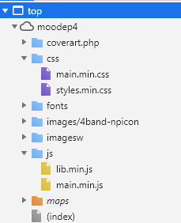
Other markup instructions comment, remove or uncomment code blocks.
There are also index.html files for use in combination with the gulp web server:
- ~moode/www/index.html – includes individual resources
- ~moode/build/develop/index.html – includes resource bundles

Complete available task list
You need only a small number of tasks, but for the overview lets see which tasks are present:

~/moode $ node_modules/.bin/gulp --tasks
[09:55:14] Tasks for ~/moode/gulpfile.js
[09:55:14] ├── listplugins
[09:55:14] ├── sass
[09:55:14] ├── browserSync
[09:55:14] ├── browserReload
[09:55:14] ├── cache
[09:55:14] ├── maps
[09:55:14] ├─┬ bundle
[09:55:14] │ └─┬ <series>
[09:55:14] │ ├── cache
[09:55:14] │ ├── maps
[09:55:14] │ └── <anonymous>
[09:55:14] ├── genindexdev
[09:55:14] ├── genindex
[09:55:14] ├── patchheader
[09:55:14] ├── patchfooter
[09:55:14] ├── minifyhtml
[09:55:14] ├── artwork
[09:55:14] ├── clean
[09:55:14] ├─┬ build
[09:55:14] │ └─┬ <series>
[09:55:14] │ ├── sass
[09:55:14] │ ├── genindexdev
[09:55:14] │ ├── genindex
[09:55:14] │ ├─┬ bundle
[09:55:14] │ │ └─┬ <series>
[09:55:14] │ │ ├── cache
[09:55:14] │ │ ├── maps
[09:55:14] │ │ └── <anonymous>
[09:55:14] │ ├── artwork
[09:55:14] │ └── <anonymous>
[09:55:14] ├─┬ deployback
[09:55:14] │ └─┬ <series>
[09:55:14] │ ├── patchheader
[09:55:14] │ ├── patchfooter
[09:55:14] │ ├── minifyhtml
[09:55:14] │ └── <anonymous>
[09:55:14] ├── deployfront
[09:55:14] ├─┬ deploy
[09:55:14] │ └─┬ <series>
[09:55:14] │ ├── deployfront
[09:55:14] │ ├─┬ deployback
[09:55:14] │ │ └─┬ <series>
[09:55:14] │ │ ├── patchheader
[09:55:14] │ │ ├── patchfooter
[09:55:14] │ │ ├── minifyhtml
[09:55:14] │ │ └── <anonymous>
[09:55:14] │ └── <anonymous>
[09:55:14] └─┬ watch
[09:55:14] └─┬ <series>
[09:55:14] ├── sass
[09:55:14] ├── genindexdev
[09:55:14] ├── browserSync
[09:55:14] └── <anonymous>

Temporary files
During running tasks a directory called ~/moode/build is created.

It contains 3 important main directories:
- cache - A cache of the minified files including the map files.
- develop – Output of a build. Contains bundles and also files to run the proxy web server.
- distr – Output of a test deploy

Full overview of the content of the build directory.
~/moode $ tree -d build
build
├── cache
│ ├── css
│ ├── js
│ └── maps
│ ├── css
│ └── js
├── develop
│ ├── css
│ ├── fonts
│ ├── images
│ │ └── toggle
│ ├── js
│ ├── maps
│ │ ├── css
│ │ └── js
│ └── webfonts
└── distr
└── var
└── www
├── command
├── css
├── fonts
├── images
├── inc
├── js
├── maps
│ ├── css
│ └── js
├── templates
└── webfonts

Prepare development host

Install required tooling:
Before you can use gulp we need to set up gulp. Like most modern webtooling Gulp is build with javascript and requires installation of npm and node.

For the raspberry pi and other flavors of Linux that support apt-get:
~ $ sudo apt-get install npm

For other platforms see https://nodejs.org/en/download/.

Checkout out work git repo
Probably you will use your own repo here, but for demonstration of the gulp tooling this ok.
~ $ git clone https://github.com/moode-player/moode.git

For the rest of the document we assume that the checkout path is ~/moode.

Setup the gulp dependencies
The tools required for using gulp are installed as self containing tools in ~/moode/node_modules. Instead of installing modules with help of the package.json , package-lock.json is used. This ensures that also the deps of deps etc are frozen to a certain version.
With the folling command those modules are installed.
~/moode $ npm ci

This will take some time. The node_modules directory is excluded in the .gitignore file so it will not bother you during your development. The node_modules doesn’t need to be reinstalled if you switch branches.

Because gulp itself is also installed as a package, running gulp requires a path to its binary. Let’s check the installation is successful:

~/moode $ node_modules/.bin/gulp -v
CLI version: 2.2.1
Local version: 4.0.2

If providing the path bothers you that much, you can install gulp global or add the node_modules/.bin to your search path.

Scenarios
In this chapter we take a look at several different uses of gulp.
The basic idea is that you always work with the checkout source and build/deploy the changed files.
I prefer using an IDE like Visual Code (runs on Mac, Windows and Linux) which make it possible to also directly edit files, commit and run commands on a remote target as Raspberry Pi.

Prepare the build of a release on the Raspberry Pi

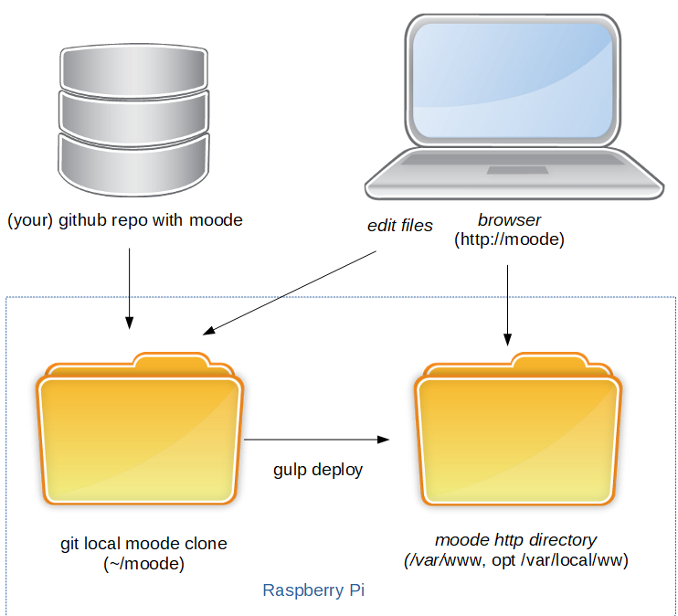
Here we bring our local branch in sync and do a deploy to the /var/www to validate the final release. We do a force to make sure newer files in the destination are overwritten even if newer.
~moode $ git fetch; git pull
~moode $ node_modules/.bin/gulp build
~moode $ sudo node_modules/.bin/gulp deploy --force
~moode $ moodeutl -r
Optional we could have done a test deploy before the real deploy:
~moode $ sudo node_modules/.bin/gulp deploy –test
You can inspect the output in build/distr.

Front-end development on development host
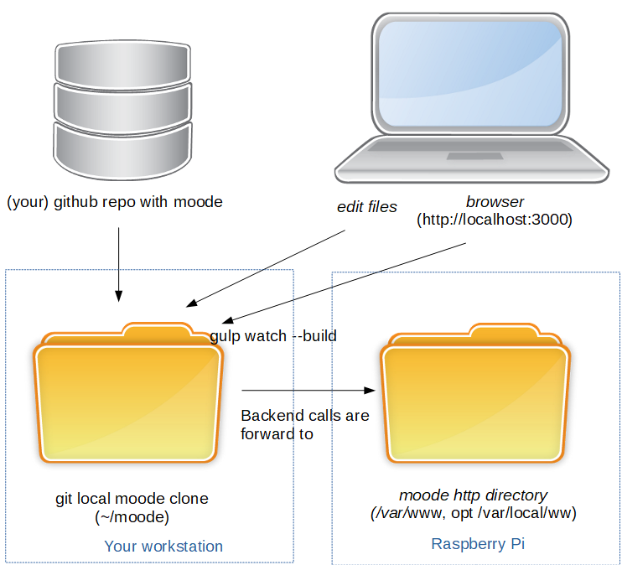
Here we assume we are working on our workstation (host as in Windows, Mac and Ubuntu) instead of on the target device Raspberry Pi (target).
The target should be running and contain a valid matching backend code.
The workflow is like:
- Start with gulp a local development web server with proxy backend calls to the target
- Editor source in your favorite editor/ide
- Save the file
- The gulp see the change an triggers a rebuild
- The browser is automatically reloaded (and your css change is visible)
The steps with gulp:
~moode $ git fetch; git pull
~moode $ node_modules/.bin/gulp watch –build
With the –build you will use the build with bundles files else without bundles.

Add the end of the gulp output you will see something like:
[Browsersync] Access URLs:
----------------------------------
Local: http://localhost:3000
External: http://0.0.0.0:3000
----------------------------------
UI: http://localhost:3001
UI External: http://localhost:3001
----------------------------------
[Browsersync] Serving files from: build/develop
Which indicates that the development web server can be reached at http://localhost:3000.
Default it will try to open a browser for you.

An important question is unanswered: how does the development web server proxy know how the raspberry pi is reachable?
It assumes that your raspberry is reachable as http://moode.test. (see package.json). You can change that setting in the package.json.

Front-end and back-end development on the Raspberry

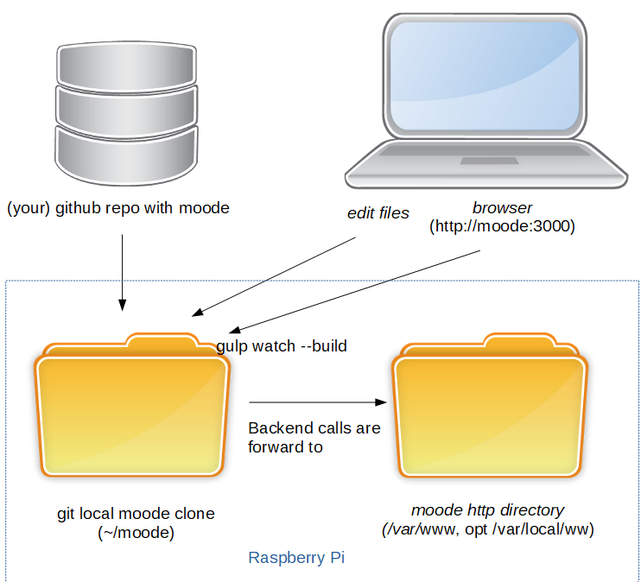
In this case you are not only doing heavy front-end work, but also back-end stuff (= php and configuration pages).
This will require working on the target device.

Every time you make a change to a backend file that needs to deployed for test you do:
First time:
~moode $ node_modules/.bin/gulp build
~moode $ sudo node_modules/.bin/gulp deploy --force
~moode $ moodeutl -r
Next time:
~moode $ sudo node_modules/.bin/gulp deploy
~moode $ moodeutl -r

For frontend changes you could also do something like:
~moode $ node_modules/.bin/gulp build
~moode $ sudo node_modules/.bin/gulp deploy --force
But in the rapid development process of web apps you will continue deploying the edit source.
As alternative we can after deploying (for the backend functionality), start the gulp web server just like we did for front-end development on another host:
~moode $ node_modules/.bin/gulp watch –build
Only we need to open a browser yourself.
If a new deploy for the backend is required ctrl-c to abort the gulp web server and do a new build/deploy.

Known issues

Gulp not found
If running gulp results in a command not found:
~moode $ gulp
gulp: command not found
Because gulp itself is also installed as a package, running gulp requires a path to its binary. Let’s check if this works:

~/moode $ node_modules/.bin/gulp -v
CLI version: 2.2.1
Local version: 4.0.2

Alternative you can add this directory to your path or install you can install gulp global:
~/moode $ sudo npm install -g gulp

Slow gulp web server
If the built in webserver is very slow, you're hitting a known issue with local networks that have .local as a domain. In that case just add to your hosts file moode.test with the specific ip number.
192.168.178.152 moode.test

And if the gulp web server is used on the Pi itself
127.0.0.1 moode.test
Pi:
If the watch webserver is running on the pi you can add the moode.test with the following command.
$ sudo sed -i.bak '${s/$/ moode.test/}' /etc/hosts
Windows:
On Windows you need to edit the file c:\Windows\System32\Drivers\etc\hosts with and text editor started with Admin rights.
Mac:

After deploy still old version in deploy location
Gulp optimizes the build and deploy by only updating new files.
In case the file in the deploy location is newer than the source it is default not overwritten. Use the argument –force to always update.

Error ‘System limit for number of file watchers reached’ on watch
If you get this error on the Raspberry Pi you can increase the number of files allowed with:

$ sudo sysctl -w fs.inotify.max_user_watches=100000

Appendix

Script to setup development environment
The following script setup gulp and prepare a development environment for a new machine.

#!/bin/bash
#
# Setup intial buildenv for moOde
#

GIT_USER_NAME="yourgithubusername"
cd ~

# increase allowed filewatches
sudo bash -c "echo \"fs.inotify.max_user_watches=100000\" > /etc/sysctl.conf"
sudo sysctl -w fs.inotify.max_user_watches=100000

sudo apt-get update
sudo apt-get -y install npm

git config --global user.name $GIT_USER_NAME
git config --global user.email "$GIT_USER_NAME@users.noreply.github.com"
git config --global credential.helper 'cache --timeout=7200'
git config --global credential.helper cache

# 1. using your own fork of moode
git clone https://github.com/$GIT_USER_NAME/moode.git
cd moode
git remote add remote https://github.com/moode-player/moode.git
git fetch remote
git checkout develop
git pull remote develop

# 2. alternative if you don’t have an fork, you can use the main repo
# git remote add remote https://github.com/moode-player/moode.git
# cd moode

npm ci

node_modules/.bin/gulp build
node_modules/.bin/gulp deploy --test

# create a backup of the original www root
sudo mv /var/www /var/www.org
sudo node_modules/.bin/gulp deploy

moodeutl -r

